Osmosis Worksheet

Answer the following questions in full sentences:
- State the definition of osmosis:
Osmosis is the diffusion/movement of water from a dilute solution to a concentrated solution through a partially permeable membrane.
- State the definition of a partially permeable membrane:
A partially permeable membrane is one which lets some substances pass through it, either out or in, e.g. a cell membrane.
- State the definitions for:
  - Hypertonic

A hypertonic solution is a solution that has a higher concentration of solute than the cell.

  - Hypotonic
A hypotonic solution is a solution that has a lower concentration of solute than the cell.

  - Isotonic
An isotonic solution is a solution that has the same concentration of solute as the cell.

- For each scenario label each side as hypotonic, hypertonic or isotonic and draw an arrow to show the net movement of water. The small dots represent water molecules and the larger dots represent sugar (the solute).
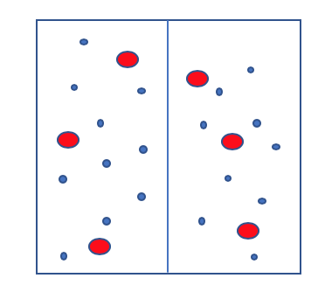
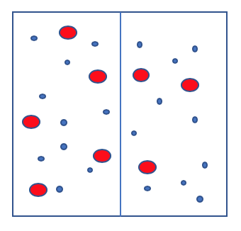
b.
a.

No net movement

Isotonic
Isotonic
Hypotonic
Hypertonic
d.
c.
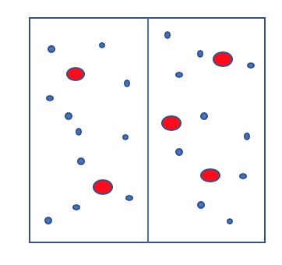
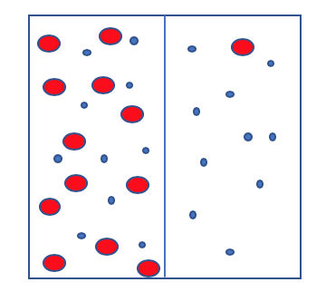

Hypotonic
Hypertonic
Hypotonic
Hypertonic

- Write a method you could use to determine the concentration inside a piece of fruit.
- Cut up some samples of the fruit, ensuring all the samples are the same size/mass
- Record the initial mass of all the samples
- Set up beakers with different concentrations (e.g. of sucrose or salt)
- Put each different sample into a different beaker and leave them for the same amount of time (e.g. 24 hours)
- Remove the samples from the beakers and wipe off any excess liquid
- Weigh each sample and record the change in mass of each one
- The sample that has not changed in mass must have been in a solution that has the same concentration as the sample

Stretch Activity
Often pupils will leave exam revision to the last minute and then stare blankly at their notes, hoping they will absorb the information by osmosis. Explain why this cannot happen.
Osmosis is the diffusion of water and it must be through a permeable membrane. ‘Information’ is not a solvent therefore cannot travel by osmosis and would also not be a small molecule, so it would not be able to pass through a partially permeable membrane.

